TOWARDS ZERO
AMBITIOUS ROAD SAFETY TARGETS AND THE SAFE SYSTEM APPROACH

Stephen Perkins
Joint Transport Research Centre of the OECD and the International Transport Forum

This is a summary of the report Towards Zero: Ambitious Road Safety Targets and the Safe System Approach, published by the OECD in October 2008. The report was the result of a three-year co-operative effort by an international group of safety experts representing 21 countries as well as the World Bank, the World Health Organisation and the FIA Foundation under the aegis of the Joint Transport Research Centre of the International Transport Forum and the Organisation for Economic Cooperation and Development (OECD).

The purpose of the report is to review the state of the art in improving road safety performance and examine the role of targets in raising the level of ambition and achieving effective implementation of road safety policies. This version of the summary of the report was prepared for and presented to the Ibero-America and the Caribbean Road Safety Conference in Madrid on 24 February 2009.

Current road safety trends
Each year around one million people are killed and 50 million people injured on roads around the world. This level of road trauma imposes huge economic costs, representing between 1 and 3 percent of GDP in most countries. In addition, deaths and disability cause great emotional and financial stress to the millions of families affected. Crashes are largely preventable. Each life saved and serious injury avoided reduces pain and suffering and achieves important economic savings.
In most OECD/ITF countries, fatalities decreased by around 50% over the period 1970-2005 but performance has not been evenly spread. The greatest regional reductions were in countries in Western Europe and the Asia-Pacific region (declines of 61% and 45%, respectively). In North America (United States and Canada), fatalities decreased by 20%, with reductions generally greater during the 1980’s than in subsequent years. Central and Eastern European Countries (CEEC) and the Commonwealth of Independent States (CIS) achieved considerable annual reductions in the 1990’s but since 2000 fatalities have stabilised in the CEEC and have increased in the CIS.
Figure 1. Change in the annual number of fatalities for the main OECD/ITF regions
1970-2005
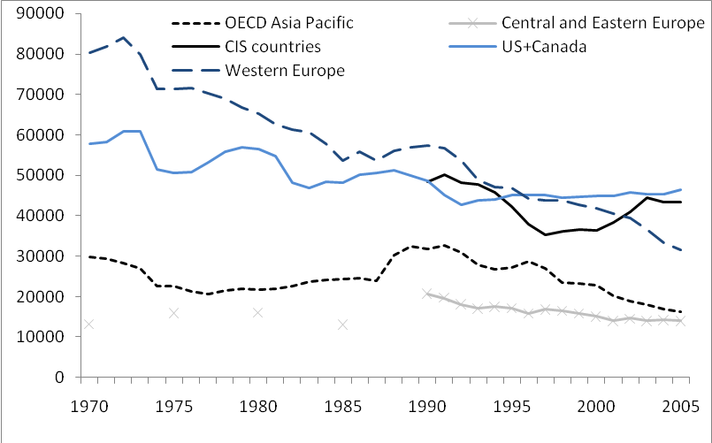
Considering individual countries, there has generally been a steady decline in fatalities per head of population since 1970 - with The Netherlands, Sweden, Switzerland, Norway, the United Kingdom, Denmark and Japan reaching rates below 6.0 fatalities per 100 000 inhabitants by 2006. However, even in countries with good performance, progress is not continuous and is marked with periods of stagnation and reversal, as shown in Figure 2.
Figure 2. Evolution in the number of fatalities between 1995 and 2007
1995 = index 100
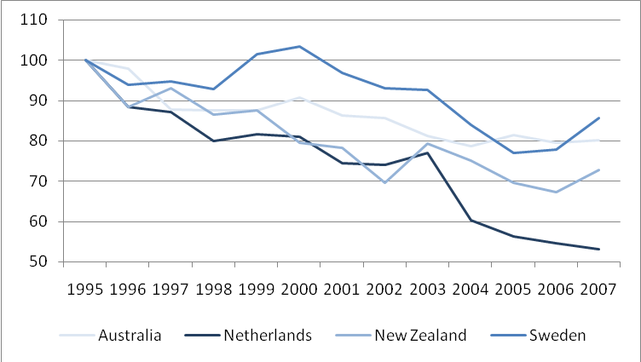

Performance against current safety targets
The value of setting targets to improve road safety performance was acknowledged in the OECD’s report Safety on the Road: What’s the Vision? (OECD, 2002). Some subsequent research suggests that countries with quantitative targets perform better than countries without targets (Wong et al 2006). Targets that are based on a comprehensive road safety vision communicate the importance of road safety, motivate stakeholders to act and help hold managers of the road transport system accountable for achieving defined results. Targets indicate that the government is committed to reducing the road toll and is likely to support proposed policy and legislative changes and allocate sufficient resources to safety programmes. Target setting is recommended as useful for all countries attempting to reduce the road toll.
Targets can be set at a number of levels. At an international level, the European Council of Ministers of Transport (ECMT) set a common target for all member countries to reduce the number of fatalities by 50% between 2000 and 2012. Many countries have also set national targets to reduce fatalities and injuries, and some have set targets also for specific regions within the country.
Setting targets does not guarantee their achievement. Few of the OECD and ITF member countries will achieve the ECMT target of a 50% reduction in fatalities by 2012 without substantial additional effort in the remaining years. However, the fact that some countries are on track to meet the target demonstrates that targeted reductions in trauma can be achieved with adequate political will, institutional organisation and sufficient allocation of resources.

What can be done in the immediate term?
Road safety performance levels particularly, in countries with lower levels of road safety performance, can be improved in the short term by implementing a battery of proven measures. A survey conducted for this report (OECD 2006-1) asked leading road safety practitioners to identify the main risks in their country. The key measures to address these risks were identified as follows.
- Speed management: enforcement of existing speed limits can provide immediate safety benefits, perhaps more quickly than any other single safety measure. Effective speed management also requires that speed limits are appropriate for the standard of the road, the roadside risks, road design, traffic volumes and mix and presence of vulnerable road users. Public support for reduced speed limits needs to be fostered, as there is generally little understanding that small decrements in speed produce substantial reductions in trauma. Other essential components of speed management are infrastructure improvement and the use of new technologies, such as intelligent speed adaptation, to modify behaviour.
- Reduced drink-driving: based on best practice experiences, highly visible enforcement using random breath testing is needed to enforce blood-alcohol limits that should not exceed 0.5g/l for the general population. Enforcement is most effective when backed by extensive publicity, with tough sanctions for repeat offenders. Alcohol interlocks fitted to all vehicles are a future option, subject to successfully increasing public acceptance.
- Seatbelt use: legislation with firm police enforcement backed by intensive mass-media programmes and penalties is the most effective strategy to improve seatbelt wearing. Technologies such as seatbelt reminder systems and seatbelt ignition interlocks could almost completely counter the non-wearing of seatbelts if introduced universally but would require community and vehicle industry acceptance.
- Safer roads and roadsides: at least for the short term, appropriate measures include targeted road improvements that identify and treat the highest crash locations with specific treatments such as audible edge-lining, shoulder sealing, clearing of roadside vegetation and the construction of passing lanes. For longer term, a systematic, proactive approach to road infrastructure design and renewal is needed.
- Enhanced vehicle safety: the safety of vehicles has increased significantly in recent years, due to technological development of passive (crash protection) and active (crash avoidance) systems. In particular, Electronic Stability Control systems represent a major recent advance in active safety, with collision avoidance and lane departure warning systems examples of other promising technologies.
- Reduced young driver risk: graduated licensing schemes in tandem with extended training during the learner period have been effective in reducing deaths among young drivers. Components of a graduated licensing can include night-driving and peer-passenger restrictions, graduated demerit points while on probation, zero blood-alcohol content tolerance and extended learning periods while under supervision to provide for driving in a variety of road and weather conditions.
These proven interventions will continue to be effective only if they are implemented with a sufficient level of intensity and are carefully matched to the individual circumstances of each country. Effective implementation also involves management processes that include analysing data to identify key problem areas, setting targets for achievement, choosing effective interventions, building community and political support, allocating sufficient resources and monitoring and evaluating performance.
Figure 3. Seatbelt wearing rates reported in a survey
undertaken for this report
2002, 2003, 2004 or 2005 data
Source: Country Reports on Road Safety Performance, OECD/ITF 2007, www.internationaltransportforum.org/jtrc/safety/targets/Performance/TS3-summary.pdf.

Improving performance in the longer term
Some traditional safety measures are likely to show a diminishing rate of return in countries that have pursued them most effectively. For example, at seatbelt wearing rates of 97% (e.g. in France for front seats), it will clearly be difficult to move closer to 100% through more intensive application of traditional education and enforcement approaches. This is seen by many experts as an indication that a new approach to road safety is necessary.
Further advances will require in the first instance, an expanded understanding of possible achievements and the development of innovative strategies and associated targets. This report contends that further major road safety gains are possible in all countries regardless of their current performance levels, through:
- Improved data collection and analysis to support longer term targets and interventions.
- Setting robust interim targets, based on an agreed strategy.
- Ambitious long term vision, building on the agreed strategy with innovation.
- Adopting a Safe System approach.
- Improving key institutional management functions.
- Supporting research and development through knowledge transfer.
- Establishing adequate funding for effective safety programmes.
- Meeting management challenges, especially building political support.
These eight points are developed below.

Data collection and analysis
Comprehensive data collection and analysis are essential for designing effective safety strategies, for setting achievable targets, for developing and determining intervention priorities and for monitoring programme effectiveness. Good quality collision statistics are essential and need to be complemented with demographic data and traffic volume data by traffic mode to generate safety performance indicators. Performance indicators can also be used as intermediate targets (such as rates of seat belt and helmet use, speeding and red light running). Data on infrastructure factors (road length by crash risk, mean travel speed, etc.) is also important.
In-depth data analyses enable past safety achievements to be understood and also allow target reductions in fatalities and injuries to be estimated on the basis of measured and expected trends. It is critical that these estimates are not simple forward projections of past reduction rates but are based on a comprehensive understanding of all the underpinning trends likely to impact on system safety.
Reliability and quality of data is a key issue, when developing road safety interventions. Even in good practice countries, there is scope for further efforts to link police collision reports to hospital data records to improve data quality and consistency, especially regarding serious injury crashes. Data quality and effective analysis are fundamental to building risk awareness and intervention effectiveness.

Setting robust interim targets
A results focus is critical to an effective road safety programme. It requires setting targets and identifying the institutional means and interventions to achieve them. The targets relate to outputs (e.g. level of enforcement), intermediate outcomes (e.g. mean travel speeds, seatbelt wearing), final outcomes (e.g. number of fatalities and serious injuries) and social costs savings.
A relatively small number of countries now use empirically derived targets, based on quantitative modelling of intervention options. In this approach, targets are based on empirical evidence relating to the selected interventions’ previous effectiveness combined with best estimates of future effectiveness, using a model linking inputs and outcomes.
This approach to setting targets is recommended. It bases targets on the achievements that can be expected from successful implementation of the interventions that make up the road safety strategy adopted. It promises immediate safety benefits through a known battery of interventions. This helps secure community support, and linking targets to an agreed strategy of interventions strengthens political support.

Ambitious long term vision
Countries with different levels of performance will have different ambitions in terms of road safety improvement. For some industrialised countries, a target fatality rate of 6 fatalities per 100 000 inhabitants will be seen as an ambitious target. Other countries have already reached this level and will aim at a higher level of ambition. Nil deaths and injuries represent the extreme level of ambition and is based on the belief that any level of serious trauma arising from the road transport system is unacceptable. This view is expressed most formally in the road safety policies of the Netherlands and Sweden known as Sustainable Safety and Vision Zero respectively, both of which are examples of a Safe System strategy. This approach is common in other transport systems and has determined safety programmes in aviation, rail and shipping for several decades.
This is an aspirational vision in that it may be impossible to specify all the interventions required to achieve this final goal. The means of achievement remain uncertain as practitioners are required to go beyond the limits of projected good practice. It therefore requires a strong commitment to innovation to reshape interventions to achieve the desired results, rather than only using current and projected performance expectations to determine them. This impetus for innovation challenges road safety professionals, stakeholders and government to develop the institutional capacity to achieve the desired results, to form new partnerships, and seek new effective approaches.
The long term vision of eliminating deaths and serious injuries needs to be complemented with robust interim targets, as described above, for specific planning terms up to a decade or so. This will help ensure the delivery of benefits over the shorter term, essential if the longer term vision is to remain credible.
Western Australia’s proposed road safety strategy for 2008-2020, Towards Zero: Getting There Together, sets out such an approach as follows. “Towards Zero means that we do not accept that any human being should die or be seriously injured on our roads. Realistically we understand that it is not practical to achieve zero serious injuries on our roads by the year 2020, but we do not accept any death or serious injury as inevitable. This vision can be achieved if the community as a whole makes a fundamental change in the way it thinks about road safety and what it is prepared to accept. Our Target by 2020: 11 000 fewer people killed or seriously injured. If the Towards Zero Strategy is fully implemented we could see up to 11 000 fewer people killed or seriously injured on Western Australian roads between 2008 and 2020, a reduction of up to 40% on the average number of people killed and seriously injured each year between 2005 and 2007”.The targeted reduction in deaths and injuries is derived from modelling the results to be expected from packages of specific interventions.
Aspirational targets for very large reductions in road trauma by specific dates have been adopted in many ITF member countries without links to specified interventions. This makes them very difficult to achieve. In the worst case, targets that fail to be achieved undermine the credibility of target setting and road safety programmes generally. Many of the countries that have adopted the ECMT target for 50% reduction in road deaths between 2000 and 2012 appear unlikely to meet it. Targets based on expected outcomes from specified interventions should therefore now be set, as a means to move systematically towards this level of ambition.
The only effective use of aspirational targets is in establishing a long term vision for achieving rates of deaths and serious injuries close to zero coupled to a twin track approach to make the vision operational: interim targets for quantified improvements over specific periods along the way, through interventions that are part of the road safety strategy; and research into more effective and new interventions to push the performance frontier.

Adopting a safe system approach
A Safe System approach is of the only way to achieve the vision of zero road fatalities and serious injuries and requires that the road system be designed to expect and accommodate human error. A Safe System approach has the following characteristics:
- It recognises that prevention efforts notwithstanding, road users will remain fallible and crashes will occur.
- It stresses that those involved in the design of the road transport system need to accept and share responsibility for the safety of the system, and those that use the system need to accept responsibility for complying with the rules and constraints of the system.
- It aligns safety management decisions with broader transport and planning decisions that meet wider economic, human and environmental goals.
- It shapes interventions to meet the long term goal, rather than relying on “traditional” interventions to set the limits of any long term targets.
The basic strategy of a Safe System approach is to ensure that in the event of a crash, the impact energies remain below the threshold likely to produce either death or serious injury. This threshold will vary from crash scenario to crash scenario, depending upon the level of protection offered to the road users involved. For example, the chances of survival for an unprotected pedestrian hit by a vehicle diminish rapidly at speeds greater than 30km/h, whereas for a properly restrained motor vehicle occupant the critical impact speed is 50km/h (for side impact crashes) and 70 km/h (for head-on crashes).
Figure 4. Fatality risk
Source: Wramborg, P. (2005). A New Approach to a Safe and Sustainable Road Structure and Street Design for Urban Areas. Paper presented at Road Safety on Four Continents Conference, Warsaw Poland.
A Safe System approach is appropriate for countries at all levels of road safety performance, with specific interventions likely to differ from country to country. The elimination of all deaths and serious injuries represents a long term goal that can be combined with traditional interventions used in the interim to achieve immediate safety benefits. Figure 5 illustrates the association between long term Safe System outcomes and interim outcomes based on traditional interventions.
Figure 5. Interim and longer term performance through the adoption of a Safe System
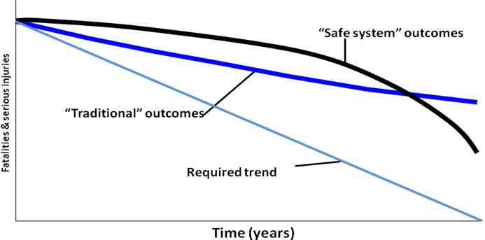
Source: Eric Howard.

Improving key institutional management functions
Because road safety performance is determined by institutional capacity to implement efficient and effective interventions, targets will be most readily met if a robust management system can be established. This system should have a clear focus on producing agreed results. Results are dependent on interventions which are in turn dependent on institutional management functions (see figure 6). Much of the day to day discussion concerning road safety centres only on interventions. Addressing all parts of the management pyramid brings in such important and often neglected issues as institutional ownership and functional capacities for road safety policies, a safety performance framework for delivery of interventions and accountability for results.
Figure 6. The road safety management system
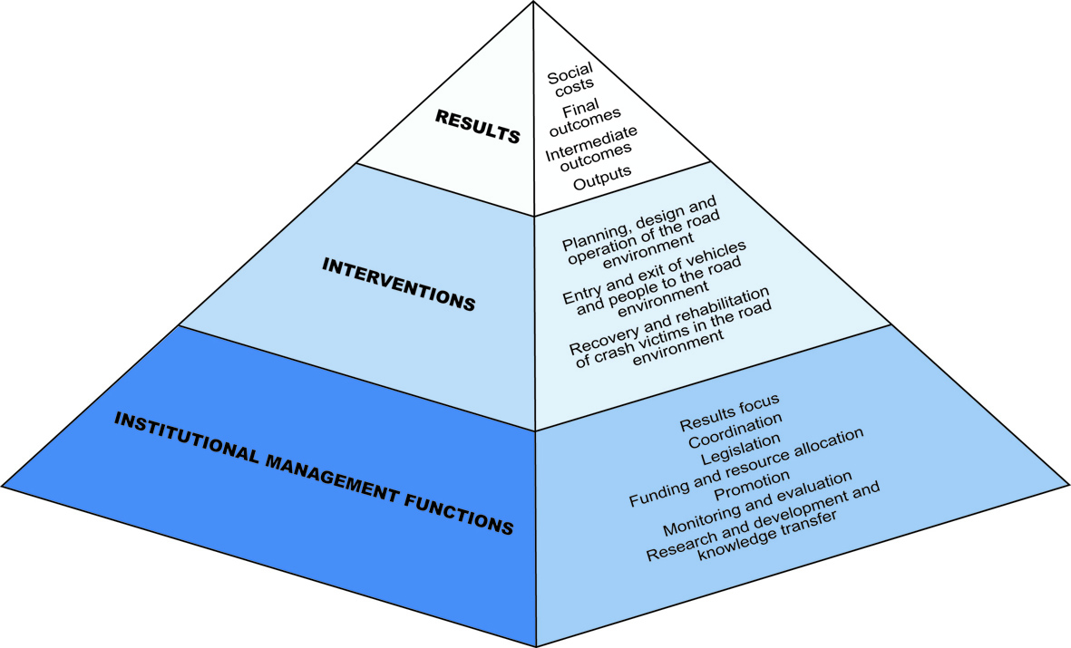
Source: Land Transport Safety Authority (2000) and Bliss & Breen (2008).
The following seven institutional management functions are critical determinants of a country’s capacity to achieve results:
- Results focus – a strategic focus that links the delivery of interventions with subsequent intermediate and final outcomes. This requires government to designate a lead agency to work with other agencies to:
- Develop management capacity to understand a country’s road safety issues.
- Provide a comprehensive strategy with intermediate and outcome targets.
- Deliver interventions and target achievements.
- Review performance.
- Coordination of the key agencies to develop and deliver road safety policy and strategy.
- Effective legislation to enable desired results to be delivered.
- Adequate funding and well targeted resource allocation for interventions and related institutional management functions.
- Promotion of road safety within government and the broader community.
- Robust and systematic monitoring and evaluation to measure progress.
- Proactive research and development and knowledge transfer programmes which actively influence improvement in interventions, institutional management functions and performance monitoring.
Above all, the commitment to a results focused approach to road safety management has a critical role in determining the achievement of a country’s road safety ambition and related targets.

Supporting research and development through knowledge transfer
Research and knowledge transfer will play a pivotal role in the design and delivery of interventions aimed at achieving a Safe System approach and in attaining results that go well beyond what has been achieved so far. Our understanding of why and how crashes occur is based on very limited research. A more complete picture would provide the basis for more effective interventions. High-income countries will rely increasingly on innovation to work towards the ultimate goal of eliminating road deaths and serious injuries. Low and middle-income countries will benefit from these advances.
Knowledge transfer priorities are shaped both by the capacity of countries to implement safety innovations and the capacity of global and regional knowledge transfer processes. In the case of low and middle-income countries, safety management capacity weaknesses present a formidable barrier to progress and must be addressed directly as a strategic priority in knowledge transfer initiatives.
Knowledge transfer must be backed by sufficient targeted investment to overcome the barriers presented by capacity weaknesses at global, regional and national levels. Strong and sustained international cooperation will be required to mobilize knowledge transfer resources and support services commensurate with the sheer scale of the global road deaths and serious injuries.

Adequate funding for effective safety programmes
Road crash costs usually represent between 1% and 3% of a country’s GDP (depending on whether a human capital or willingness to pay approach is used). While a survey conducted for this report shows that many countries are unable to estimate the annual costs of road trauma to government and injury insurers, the available evidence suggests that costs substantially outweigh the funds put into prevention programmes.
The adoption of a Safe System approach can produce important economic savings for society. To compete successfully for limited resources with other political and social programmes the road safety case needs to include sound economic arguments. This requires road safety managers to be skilled in assembling business cases for initiatives, including economic analysis. In particular, accurate estimates of crash costs are necessary to show the scale of the problem and to attract investment in road trauma prevention.
Components of an effective business case include:
- A solid evaluation framework to assess the economic and social scale of the current problem, to analyse injury causation data, to prioritise possible interventions (using cost benefit and cost effectiveness analyses) and to identify the socio-economic returns of expenditures on road safety.
- An allocation and implementation process that delivers resources to areas where the greatest benefits will be generated.
- Identification of any potential additional funding resources outside government, including encouragement for injury insurer investment in road trauma prevention.
Cost benefit analyses from various member countries show that carefully targeted road safety activity can be a viable investment opportunity, providing a competitive return for the insurance industry as well as government especially when the aggregate costs to the two sectors are considered and not solely the costs to government. Opportunities to attract funding by offering commercially acceptable rates of return for investors need to be vigorously pursued.

Meeting management challenges – building political support
While strong political support is critical for achieving ambitious targets, road safety may often be a hard sell to politicians. Many factors including the level of public interest and public pressure, the economic and political feasibility of solutions and the prospects of demonstrable success determine whether road safety will be treated as a government priority.
Road safety policy makers and advocates need to provide sound advice to government on policies while also accommodating the practical realities of political decision-making by:
- Empirically demonstrating the value of perhaps unpopular road safety policies, to enable politicians to stand firm in the face of opposition.
- Promoting policies that will show positive results within in a timeframe relevant to politicians.
- Displaying an appreciation of the practical realities of political decision-making, including the election cycle.
- Consistently providing competent, timely advice on a day to day basis.
- Carrying out effective policy advocacy at all levels of government.
Politicians need to be engaged in the process of developing the vision for road safety and the strategy for improving performance and not just the legislative process and approval of targets. Ownership of the vision and strategy is more likely to generate the funding and support for management capacity development and training required.
It is also useful to promote the synergies between road safety policies and other policy areas such as occupational health, consumer rights and environmental protection. For example, reductions in greenhouse gas emissions can be achieved through improved speed management to reduce crash risk.
Public opinion represents a key stimulus to political will for road safety. It will always be easier for a government to make road safety a priority if the public supports the effort. Activities such as publishing information on crash risks and measured safety performance may mobilise public as well as political support for road safety. Genuine consultation during strategy development should be integral elements of government road safety activity.
There is a strong and growing market for safety, evidenced by consumer vehicle purchase preferences in response to information programs such as NCAP, by safety programmes for child travel to and from schools and by the demand for the safer operation of public transport and freight activities on the road network. Support for this growing momentum is also evident in the private sector, where organisations such as Volvo, oil and mining companies and motoring associations are making strong statements about the future safety of their products and their operations.

Recommendations

1. Adopt a highly ambitious vision for road safety
All countries are advised to adopt and promote a level of ambition that seeks in the long term to eliminate death and serious injury arising from use of the road transport system. Adopting this ambition will alter the community’s view of the inevitability of road trauma, alter institutional and societal responsibilities and accountability and change the way in which road safety interventions are shaped.
This is an aspirational vision in that achievement will require interventions that are some steps removed from prevailing best practice and will require the development of altogether new, more effective interventions. Part of its value lies in driving innovation. The long term vision needs to be complemented with interim targets for specific planning periods up to a decade or so.

2. Set interim targets to move systematically towards the vision
Ambitious, achievable and empirically-derived road safety targets should be adopted by all countries to drive improved performance and accountability. These targets should be developed by using a methodology that links interventions and institutional outputs with intermediate and final outcomes to develop achievable targets for different intervention options.
Exceptional efforts will be required in most OECD and ITF countries to achieve the road safety targets set by Transport Ministers in 2002 - 50% reduction in deaths between 2000 and 2012, or similar ambitious targets. Accordingly, it is recommended that targets based on expected outcomes from specified interventions now be established, as a means to move more systematically towards the level of ambition established by the targets set in 2002.

3. Develop a Safe System approach, essential for achieving ambitious targets
It is recommended that all countries, regardless of their level of road safety performance, move to a Safe System approach to road safety. This approach: builds on existing road safety interventions but reframes the way in which road safety is viewed and managed in the community. It addresses all elements of the road transport system in and integrated way with the aim of ensuring crash energy levels are below what would to cause fatal or serious injury. It requires acceptance of shared overall responsibilities and accountability between system designers and road users. It stimulates the development of the innovative interventions and new partnerships necessary to achieve ambitious long term targets.

4. Exploit proven interventions for early gains
Countries experiencing difficulty in improving their road safety performance should as a matter of urgency conduct high-level reviews of their safety management capacity and prepare long-term investment strategies and related programs and projects to overcome revealed capacity weaknesses. These programmes and projects should adapt and implement proven institutional management arrangements and interventions used in more successful countries, and make use of good practice tools developed by international agencies to assist this process.

5. Conduct sufficient data collection and analysis to understand crash risks
and current performance
All countries are encouraged to develop data collection procedures to cover: final outcomes (including at least deaths and serious injuries by road user); exposure measures (for example, relating outcomes to population levels, licensed driver numbers, distances travelled); intermediate outcomes (also called safety performance indicators and including levels of mean traffic speeds, seat belt wearing, drink driving and vehicle and infrastructure safety ratings); institutional delivery outputs (including different categories of enforcement effort); socio-economic costs associated with road trauma; and underlying economic factors (including new vehicle sales).
Careful data analysis should be conducted to improve understanding of crash and other trends to allow different intervention mixes and intensities to be modelled and ambitious but achievable targets to be set.

6. Strengthen the road safety management system
All countries should commit to ensuring an effective road safety management system and in particular seek to achieve a strong results focus through their institutional management arrangements. This results focus requires clear identification of: a lead agency; the core group of government ministries and agencies to be involved; their roles and responsibilities; and the performance targets in terms of institutional outputs and intermediate and final outcomes to be achieved within a defined strategy.

7. Accelerate knowledge transfer
Knowledge transfer initiatives must be supported with adequate investment in targeted programs and projects, designed to overcome institutional capacity weaknesses, especially by creating sustainable learning opportunities in the countries concerned.
Strong and sustained international cooperation will be required to mobilize resources and support commensurate with the scale of the losses arising from road deaths and serious injuries. This is especially the case with low and middle-income countries, but it is also relevant to high-income countries seeking innovative strategies for achieving the ultimate goal of eliminating death and serious injury.

8. Invest in road safety
Most countries need to improve their knowledge of expenditure on the consequences of road crashes, both by government and injury insurance companies, and investment in road safety improvement and trauma prevention. Road safety authorities need this information to prepare financial and economic evidence on the costs and effectiveness of proposed interventions in order to win whole-of-government support for funding innovative programmes and for transparency in resource allocation for crash prevention and treatment.
There are opportunities for targeted road safety investments that provide competitive returns. Road safety practitioners and authorities should develop business cases for this investment.
A step change in resources invested in road safety management and in safer transport systems is required to realise the achievement of ambitious road safety targets in most of the world.

9. Foster commitment at the highest levels of government
Sustained government commitment at the highest level is essential for improving road safety. To secure this, road safety managers not only need to develop evidence-based road safety programmes but need to advocate strategies that reflect an understanding of political constraints such as the electoral cycle.
Significant effort needs to be directed at informing the public about the Safe System approach. Public consultation should be comprehensive and should precede final political consideration of new policies.
Road safety practitioners and stakeholders have a responsibility to influence the political process of policy assessment through: competent and persistent advocacy of programmes within government, provision of annual estimates of the socio-economic costs of road trauma and development of an extensive armoury of effective road safety interventions.

